
Touchstones
Netcards

Sabbath Netcards with Text

Bobolink HRJ
Breathe HRJ
Care HRJ
Church HRJ

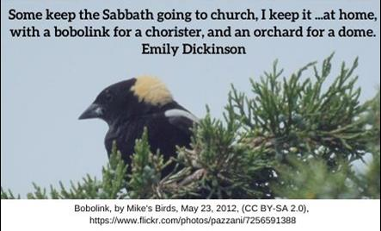

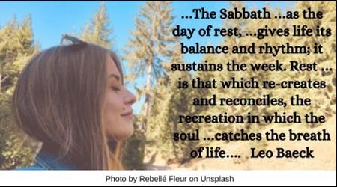

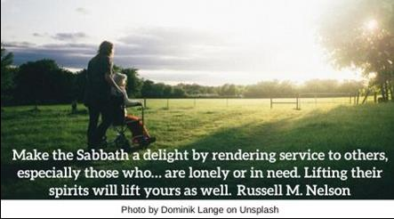

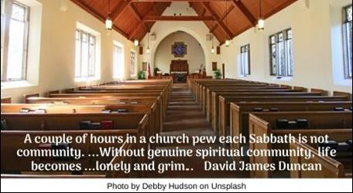

Day Off HRJ
Emptiness HRJ
Extravagant HRJ
Flowers HRJ

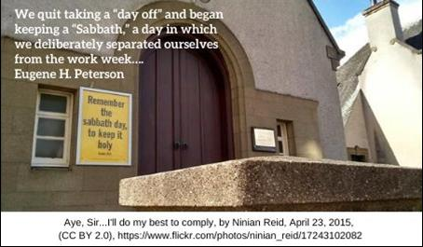

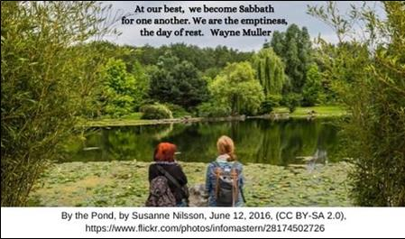

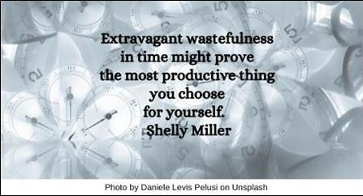

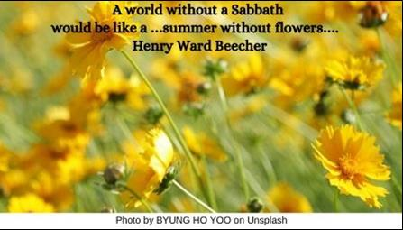

Garden HRJ
Heart HRJ
Library HRJ
Mountain Top HRJ

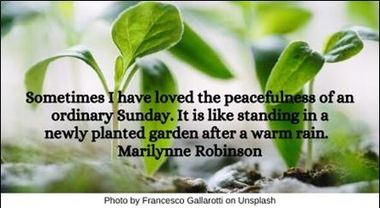

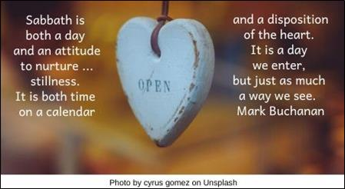

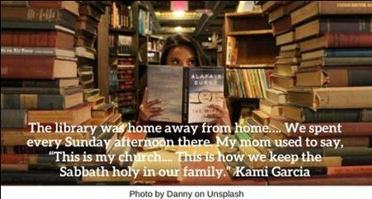

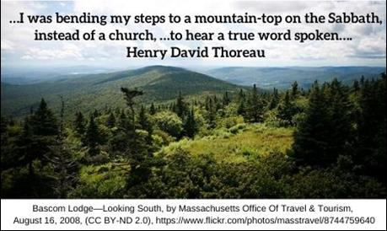

No Burden HRJ
No Work HRJ
Notice HRJ
Path HRJ

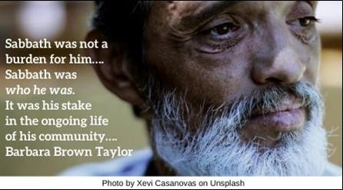

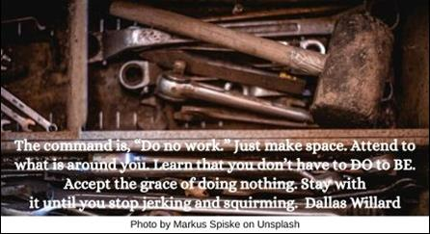

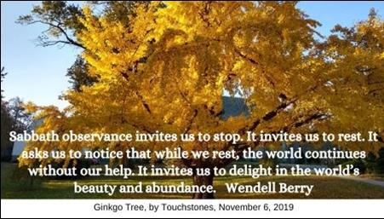

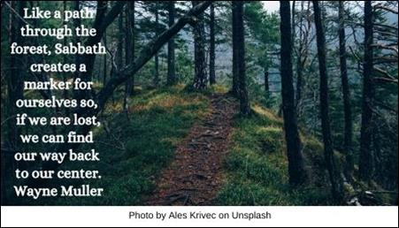

Rest HRJ
Sabbath-keeping HRJ
Sacred HRJ
Sacred Time HRJ

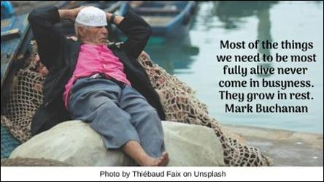

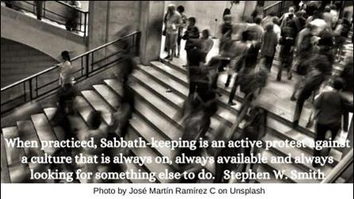

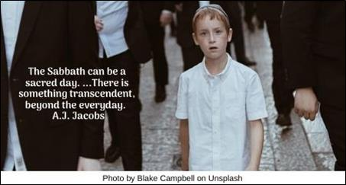

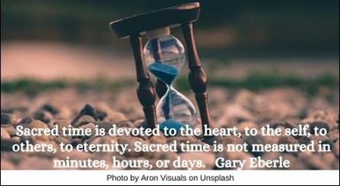

Seventh HRJ
Sits HRJ
Solitude HRJ
Stop HRJ

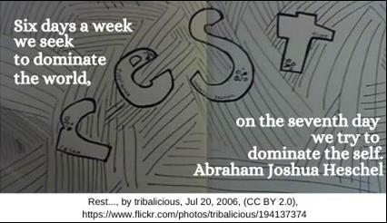

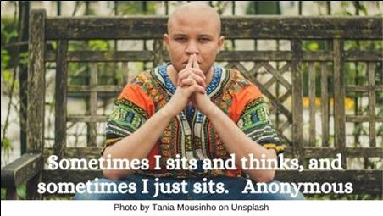

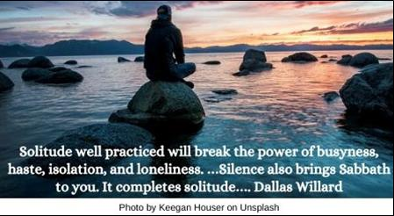

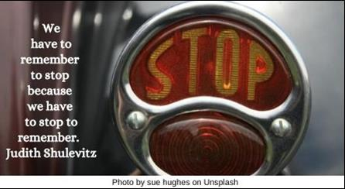

The Week HRJ
Tired HRJ
To Do HRJ
Wall Street HRJ

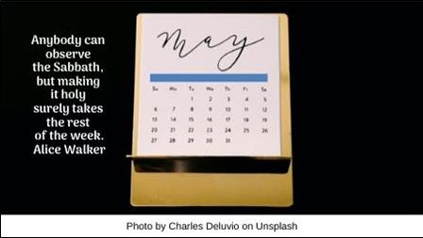

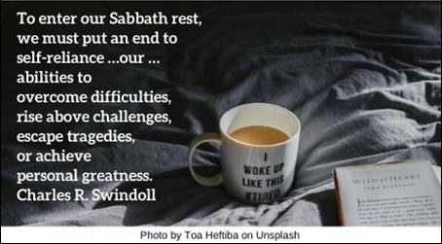

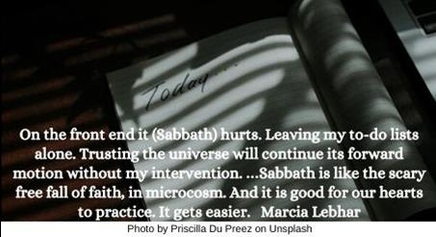

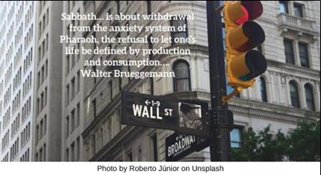

Wings HRJ
Work HRJ
Work is Done HRJ

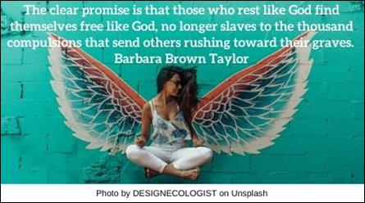

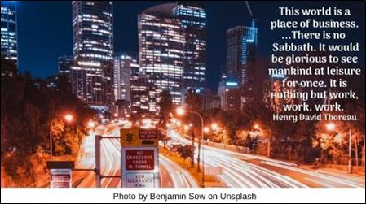

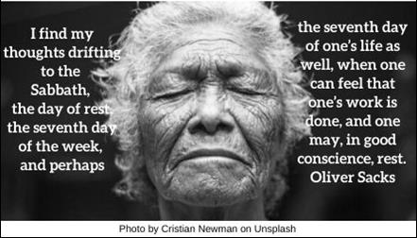

Text of Quotes
Bobolink
Some keep the Sabbath going to church, I keep it staying at home, with a bobolink for a chorister, and an orchard for a dome. Emily Dickinson

Breathe
…The Sabbath …as the day of rest, …gives life its balance and rhythm; it sustains the week. Rest …is that which re-creates and reconciles, the recreation in which the soul …catches the breath of life…. Leo Baeck

Care
Make the Sabbath a delight by rendering service to others, especially those who… are lonely or in need. Lifting their spirits will lift yours as well. Russell M. Nelson

Church
A couple of hours in a church pew each Sabbath is not community. …Without genuine spiritual community, life becomes …lonely and grim…. David James Duncan

Day Off
We quit taking a “day off” and began keeping a “Sabbath,” a day in which we deliberately separated ourselves from the work week…. Eugene H. Peterson

Emptiness
At our best, we become Sabbath for one another. We are the emptiness, the day of rest. Wayne Muller

Extravagant
Extravagant wastefulness in time might prove the most productive thing you choose for yourself. Shelly Miller

Flowers
A world without a Sabbath would be like a …summer without flowers…. Henry Ward Beecher
Garden
Sometimes I have loved the peacefulness of an ordinary Sunday. It is like standing in a newly planted garden after a warm rain. Marilynne Robinson

Heart
Sabbath is both a day and an attitude to nurture such stillness. It is both time on a calendar and a disposition of the heart. It is a day we enter, but just as much a way we see. Mark Buchanan

Library
The library was home away from home…. We spent every Sunday afternoon there. My mom used to say, “This is my church, Ethan. This is how we keep the Sabbath holy in our family.” Kami Garcia

Mountain Top
…I was bending my steps to a mountain-top on the Sabbath, instead of a church, …to hear a true word spoken…. Henry David Thoreau

No Burden
Sabbath was not a burden for him…. Sabbath was who he was. It was his stake in the ongoing life of his community…. Barbara Brown Taylor

No Work
The command is, “Do no work.” Just make space. Attend to what is around you. Learn that you don’t have to DO to BE. Accept the grace of doing nothing. Stay with it until you stop jerking and squirming. Dallas Willard

Notice
Sabbath observance invites us to stop. It invites us to rest. It asks us to notice that while we rest, the world continues without our help. It invites us to delight in the world’s beauty and abundance. Wendell Berry

Path
Like a path through the forest, Sabbath creates a marker for ourselves so, if we are lost, we can find our way back to our center. Wayne Muller

Rest
Most of the things we need to be most fully alive never come in busyness. They grow in rest. Mark Buchanan

Sabbath-keeping
When practiced, Sabbath-keeping is an active protest against a culture that is always on, always available and always looking for something else to do. Stephen W. Smith

Sacred
The Sabbath can be a sacred day. …There is something transcendent, beyond the everyday. A.J. Jacobs

Sacred Time
Sacred time is devoted to the heart, to the self, to others, to eternity. Sacred time is not measured in minutes, hours or days. Gary Eberle

Seventh
Six days a week we seek to dominate the world, on the seventh day we try to dominate the self. Abraham Joshua Heschel

Sits
Sometimes I sits and thinks, and sometimes I just sits. Anonymous

Solitude
Solitude well practiced will break the power of busyness, haste, isolation, and loneliness. …Silence also brings Sabbath to you. It completes solitude…. Dallas Willard

Stop
We have to remember to stop because we have to stop to remember. Judith Shulevitz

The Week
Anybody can observe the Sabbath, but making it holy surely takes the rest of the week. Alice Walker

Tired
To enter our Sabbath rest, we must put an end to self-reliance …our …abilities to overcome difficulties, rise above challenges, escape tragedies, or achieve personal greatness. Charles R. Swindoll

To Do
On the front end it (Sabbath) hurts. Leaving my to-do lists alone. Trusting the universe will continue its forward motion without my intervention. …Sabbath is like the scary free fall of faith, in microcosm. And it is good for our hearts to practice. It gets easier. Marcia Lebhar

Wall Street
Sabbath… is about withdrawal from the anxiety system of Pharaoh, the refusal to let one’s life be defined by production and consumption…. Walter Brueggemann

Wings
The clear promise is that those who rest like God find themselves free like God, no longer slaves to the thousand compulsions that send others rushing toward their graves. Barbara Brown Taylor

Work
This world is a place of business. …There is no sabbath. It would be glorious to see mankind at leisure for once. It is nothing but work, work, work. Henry David Thoreau

Work is Done
I find my thoughts drifting to the Sabbath, the day of rest, the seventh day of the week, and perhaps the seventh day of one’s life as well, when one can feel that one’s work is done, and one may, in good conscience, rest. Oliver Sacks

